***Assignment #10***

Create a FSM that works as a sequence detector that receives a bit‐serial input X and asserts an output Z (i.e. Z = 1) when it detects a binary string 0110 in sequence of 0s and 1s. You need to provide the following components:

1. Input set A
2. Internal states set S
3. Output set Z
4. Initial state
5. State diagram

A={0,1}

S={S0,S1,S2,S3,S4}

Z={0,1}

Initial State S0

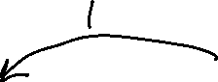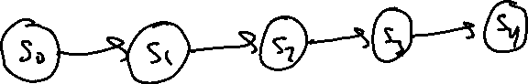

State table

|  |  |  |  |  |  |  |  |
| --- | --- | --- | --- | --- | --- | --- | --- |
| **Current State** | | | **Input** | **Next state** | | | **Output** |
| **S0** | **S1** | **S3** | **X** | **\*s0** | **\*s1** | **\*s2** | **Z** |
| 0 | 0 | 0 | 0 | 0 | 0 | 1 | 0 |
| 0 | 0 | 0 | 1 | 0 | 0 | 0 | 0 |
| 0 | 0 | 1 | 0 | 0 | 0 | 1 | 0 |
| 0 | 0 | 1 | 0 | 0 | 0 | 1 | 0 |
| 0 | 1 | 0 | 0 | 0 | 0 | 1 | 0 |
| 0 | 1 | 0 | 0 | 0 | 0 | 1 | 0 |
| 0 | 1 | 1 | 0 | 1 | 0 | 0 | 1 |
| 0 | 1 | 1 | 1 | 0 | 0 | 0 | 0 |
| 1 | 0 | 0 | 0 | 0 | 0 | 1 | 0 |
| 1 | 0 | 0 | 1 | 0 | 1 | 0 | 0 |